**Downloading**

1. Copy the address (https://github.com/slagKupczak/SLAG.git) to your browser
2. Click on the arrow next to "Code" and then click "Download ZIP" (Fig. 1)

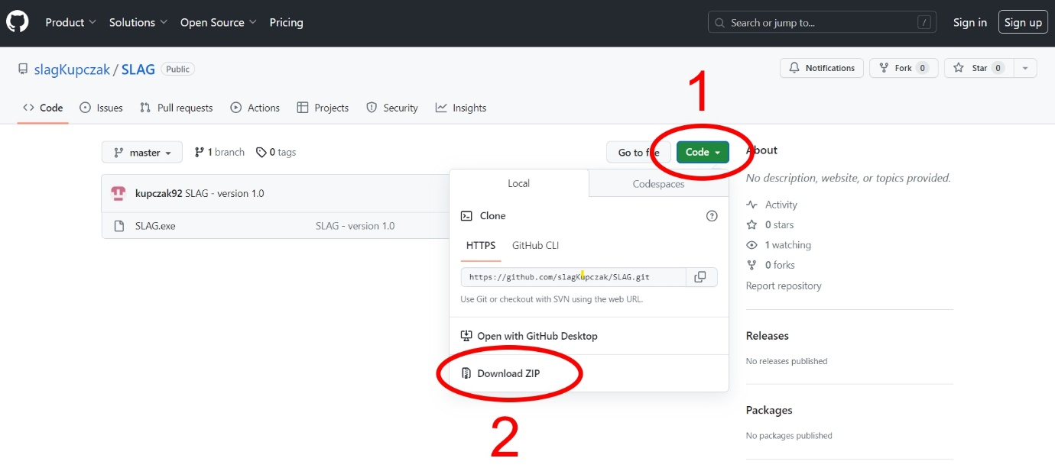

Figure 1 SLAG software page on github

1. After downloading, just unzip the folder
2. Antivirus programs will most likely block the program from opening. This is because we are not professional software publishers.

**Using**

1. It is important that all fields are filled in before clicking "Calculate". If an oxide does not occur in the slags, enter 0. The temperature must be entered in the Viscosity and Predominance Area Diagrams tabs.
2. Each time before creating charts, you must perform a calculation by clicking "Calculate"
3. You can use "." to separate fractional parts. or ",".